Packet Tracer – Verifying and Troubleshooting NAT Configurations

1. Topology

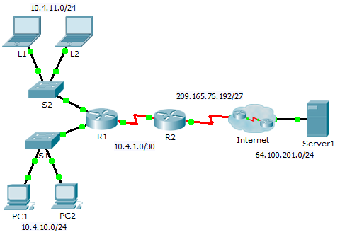

1. Addressing Table

|  |  |  |  |  |
| --- | --- | --- | --- | --- |
| Device | Interface | IP Address | Subnet Mask | Default Gateway |
| R1 | G0/0 | 10.4.10.254 | 255.255.255.0 | N/A |
| G0/1 | 10.4.11.254 | 255.255.255.0 | N/A |
| S0/0/1 | 10.4.1.2 | 255.255.255.252 | N/A |
| R2 | S0/0/0 | 209.165.76.194 | 255.255.255.224 | N/A |
| S0/0/1 | 10.4.1.1 | 255.255.255.252 | N/A |
| Server1 | NIC | 64.100.201.5 | 255.255.255.0 | 64.100.201.1 |
| PC1 | NIC | 10.4.10.1 | 255.255.255.0 | 10.4.10.254 |
| PC2 | NIC | 10.4.10.2 | 255.255.255.0 | 10.4.10.254 |
| L1 | NIC | 10.4.11.1 | 255.255.255.0 | 10.4.11.254 |
| L2 | NIC | 10.4.11.2 | 255.255.255.0 | 10.4.11.254 |

1. Objectives

Part 1: Isolate Problems

Part 2: Troubleshoot NAT Configuration

Part 3: Verify Connectivity

1. Scenario

A contractor restored an old configuration to a new router running NAT. But, the network has changed and a new subnet was added after the old configuration was backed up. It is your job to get the network working again.

1. Isolate Problems

Ping **Server1** from **PC1**, **PC2**, **L1**, **L2**, and **R2**. Record the success of each ping. Ping any other machines as needed.

1. Troubleshoot NAT Configuration
   1. View the NAT translations on R2.

If NAT is working, there should be table entries.

* 1. Show the running configuration of R2.

The NAT inside port should align with the private address, while the NAT outside port should align with the public address.

* 1. Correct the Interfaces.

Assign the **ip nat inside** and **ip nat outside** commands to the correct ports.

**int s0/0/0**

**ip nat outside**

**int s0/0/1**

**ip nat inside**

* 1. Ping Server1 from PC1, PC2, L1, L2, and R2.

Record the success of each ping. Ping any other machines as needed.

* 1. View the NAT translations on R2.

If NAT is working, there should be table entries.

* 1. Show Access-list 101 on R2.

The wildcard mask should encompass both the 10.4.10.0 network and the 10.4.11.0 network.

* 1. Correct the Access-list.

Delete access-list 101 and replace it with a similar list that is also one statement in length. The only difference should be the wildcard.

**no access-list 101**

**access-list 101 permit ip 10.4.10.0 0.0.1.255 any**

1. Verify Connectivity
   1. Verify connectivity to Server1.

Record the success of each ping. All hosts should be able to ping **Server1**, **R1**, and **R2**. Troubleshoot if the pings are not successful.

* 1. View the NAT translations on R2.

NAT should display many table entries.